**LAPORAN PROYEK 5**

**BOTTOM UP DATABASE DESAIN**

**PADA SISTEM INFORMASI (APLIKASI)**

**PERPUSTAKAAN**



**OLEH:**

**AHMADI MUSLIM**

**NISN. 91287491261**

**REKAYASA PERANGKAT LUNAK**

**SMK NEGERI 1 KARANG BARU**

**PEMERINTAH PROVINSI ACEH**

**2023**

**LAPORAN PRAKTIKUM BASIS DATA**

**Create, Read, Update, dan Delete (CRUD) / DDL, DML, DCL, TCL**

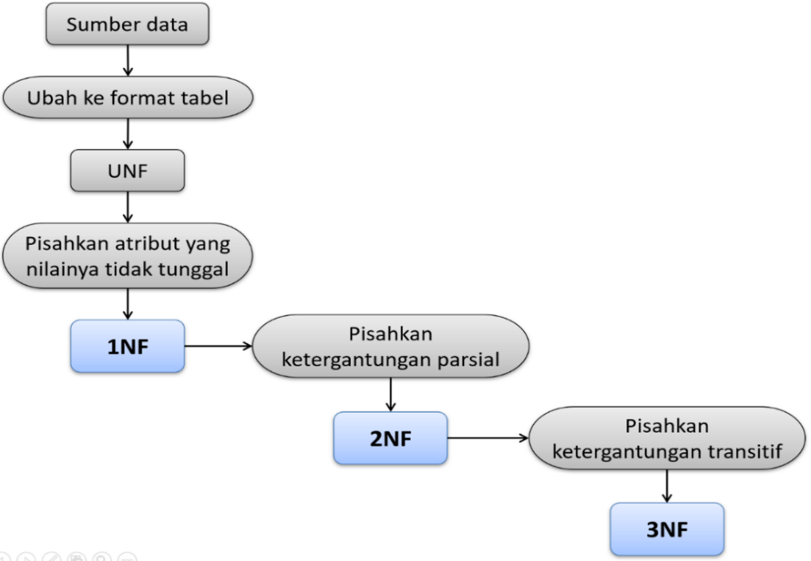



**Tugas…!  
Kerjakan Instruksi Berikut Ini .!**

1. Ekstraksi/konversi Tabel (unf)

|  |  |  |  |  |  |  |  |
| --- | --- | --- | --- | --- | --- | --- | --- |
| kodepinjam | kodeanggota | namaanggota | kodebuku | judulbuku | tglpinjam | jatuhtempo | admin |
|  |  |  |  |  |  |  |  |
|  |  |  |  |  |  |  |  |

1. Normalisasi Tabel

**1nf**

|  |  |  |  |  |  |  |  |
| --- | --- | --- | --- | --- | --- | --- | --- |
| bukti peminjaman buku | | | | | | | |
| kodepinjam | kodeanggota | namaanggota | kodebuku | judulbuku | tglpinjam | jatuhtempo | admin |
| pj006 | a008 | Rahma Dewita | B010 | Akuntansi | 5/18/2015 | 5/25/2015 | pt01 |

**2nf**

|  |  |  |  |  |  |  |  |  |  |  |  |  |  |
| --- | --- | --- | --- | --- | --- | --- | --- | --- | --- | --- | --- | --- | --- |
| anggota | |  | pinjam | | | |  | buku | |  | admin | |  |
| kodeanggota | namaanggota |  | kodepinjam | tglpinjam | jatuhtempo | admin |  | kodebuku | judulbuku |  | Kodeadmin | namaadmin | password |
| a008 | Rahma Dewita |  | pj006 | 5/18/2015 | 5/25/2015 | pt01 |  | B010 | Akuntansi |  |  |  |  |

**3nf**

|  |  |  |  |  |  |  |  |  |  |  |  |  |  |  |  |  |
| --- | --- | --- | --- | --- | --- | --- | --- | --- | --- | --- | --- | --- | --- | --- | --- | --- |
| anggota | |  | pinjam | | |  | detil pinjam | | |  | buku | |  | admin | |  |
| kodeanggota | namaanggota |  | kodepinjam | kodebuku | kodeanggota |  | tglpinjam | jatuhtempo | admin |  | kodebuku | judulbuku |  | kodeadmin | namaadmin | password |
| a008 | RAHMA DEWITA |  | pj006 | B010 | a008 |  | 5/18/2015 | 5/25/2015 | pt01 |  | B010 | Akuntansi |  |  |  |  |

1. Membuat ER-Diagram



1. Membuat ER-Table



1. Membuat Source SQL

**Tabel anggota**

|  |  |  |  |  |  |
| --- | --- | --- | --- | --- | --- |
| **No** | **Nama kolom** | **Tipe data** | **Lebar** | **Null** | **kunci** |
| 1 | kodeanggota | char | 10 | not null | primary key |
| 2 | namaanggota | varchar | 30 |  |  |
| 3 | alamatanggota | varchar | 50 |  |  |

create table anggota (

kodeanggota char (10) not null,

namaanggota varchar (30) not null,

alamatanggota varchar (50),

primary key (kodeanggota)

);

**Tabel admin**

|  |  |  |  |  |  |
| --- | --- | --- | --- | --- | --- |
| **No** | **Nama kolom** | **Tipe data** | **Lebar** | **Null** | **kunci** |
| 1 | kodeadmin | char | 10 | not null | primary key |
| 2 | namaadmin | varchar | 30 |  |  |
| 3 | password | varchar | 50 |  |  |
| 4 | alamatadmin |  |  |  |  |

create table admin (

kodeadmin char (10) not null,

namaadmin varchar (30) not null,

password varchar (10),

alamatadmin varchar (50),

primary key (kodeadmin)

);

**Tabel buku**

|  |  |  |  |  |  |
| --- | --- | --- | --- | --- | --- |
| **No** | **Nama kolom** | **Tipe data** | **Lebar** | **Null** | **kunci** |
| 1 | kodebuku | char | 10 | not null | primary key |
| 2 | judulbuku | varchar | 30 |  |  |
| 3 | penerbit | varchar | 50 |  |  |

create table buku (

kodebuku char (10) not null,

judulbuku varchar (50) not null,

penerbit varchar (30),

primary key (kodebuku)

);

**Tabel pinjam**

|  |  |  |  |  |  |
| --- | --- | --- | --- | --- | --- |
| **No** | **Nama kolom** | **Tipe data** | **Lebar** | **Null** | **kunci** |
| 1 | kodepinjam | char | 10 | not null | primary key |
| 2 | kodeanggota | char | 10 | not null | foreignkey |
| 3 | kodebuku | char | 10 | not null | foreignkey |

create table pinjam (

kodepinjam char (10) not null,

kodeanggota char (10) not null,

kodebuku char (10) not null,

primary key (kodepinjam),

**constraint kodeanggota foreign key (kodeanggota) references anggota (kodeanggota),**

**constraint kodebuku foreign key (kodebuku) references buku (kodebuku)**

);

**Tabel detilpinjam**

|  |  |  |  |  |  |
| --- | --- | --- | --- | --- | --- |
| **No** | **Nama kolom** | **Tipe data** | **Lebar** | **Null** | **kunci** |
| 1 | kodedetilpinjam | char | 10 | not null | primary key |
| 2 | kodeadmin | char | 10 | not null | foreignkey |
| 3 | kodepinjam | char | 10 | not null | foreignkey |
|  | tanggalpinjam |  |  |  |  |
|  | jatuhtempo |  |  |  |  |

create table detilpinjam (

kodedetilpinjam char (10) not null,

kodeadmin char (10) not null,

kodepinjam char (10) not null,

tanggalpinjam varchar (30),

jatuhtempo varchar (14),

primary key (kodedetilpinjam),

**constraint kodeadmin foreign key (kodeadmin) references admin (kodeadmin),**

**constraint kodepinjam foreign key (kodepinjam) references pinjam (kodepinjam)**

);

1. Membuat Database Di Phpmysadmin Melalui SQL

**Tabel anggota**

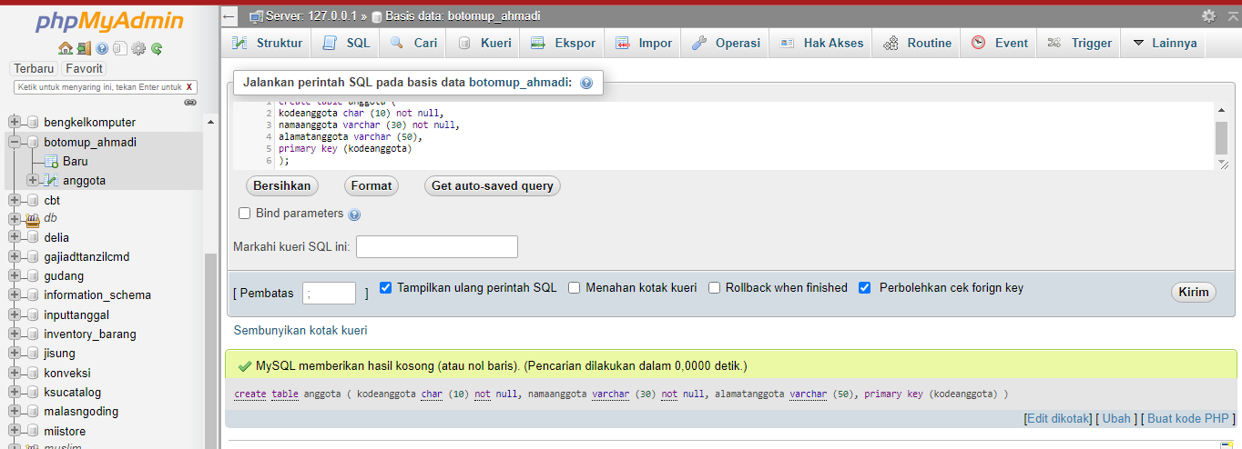

**Tabel admin**

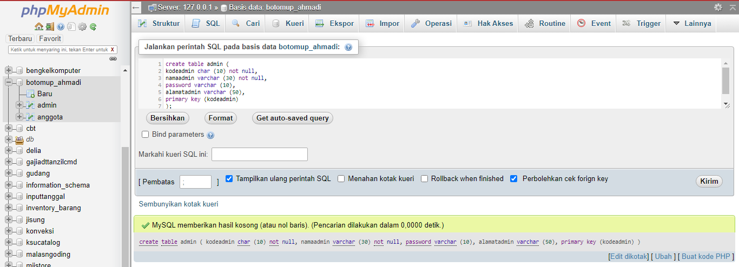

**Tabel buku**

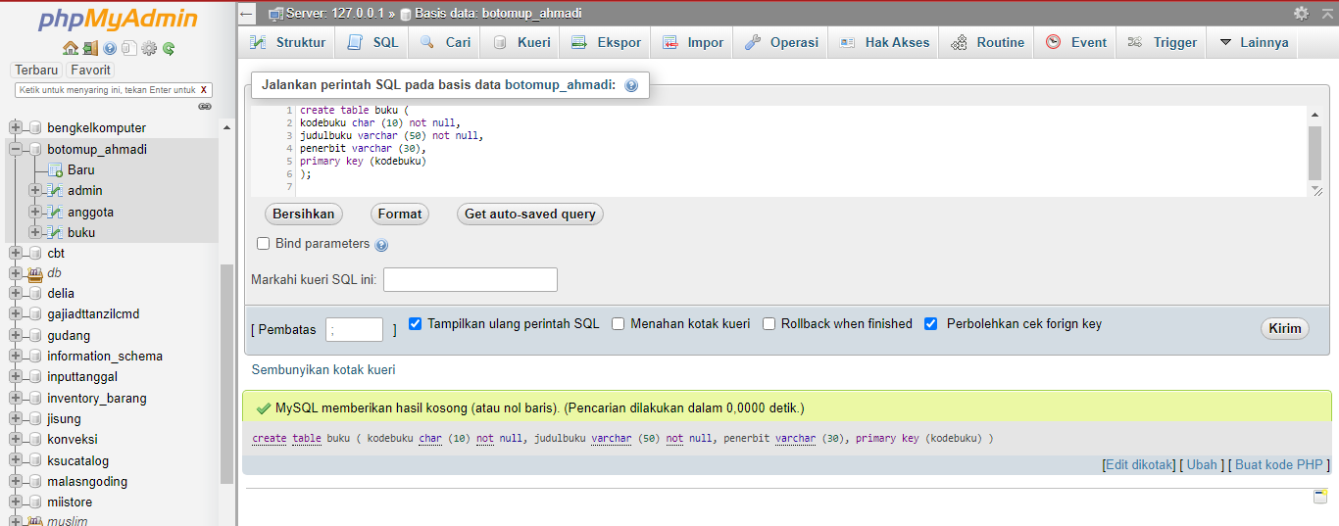

**Tabel pinjam**

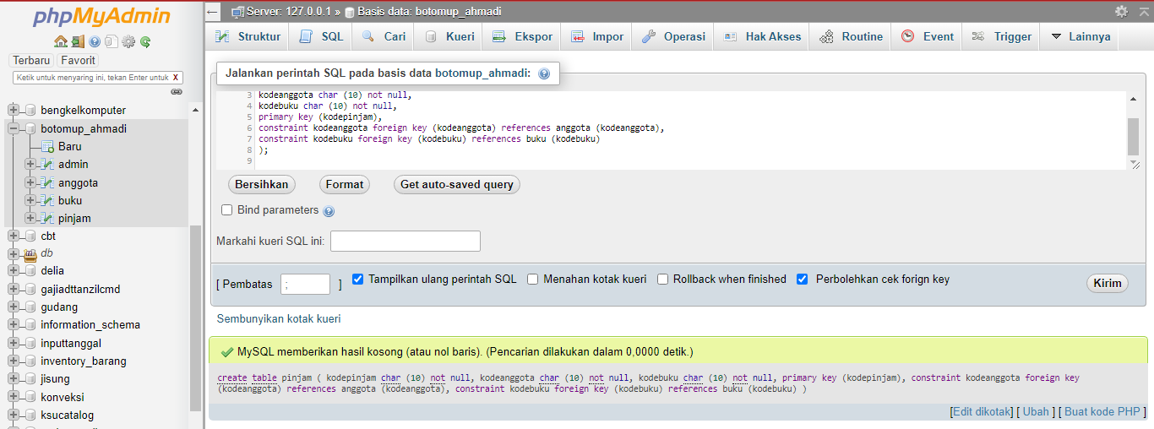

**Tabel detilpinjam**

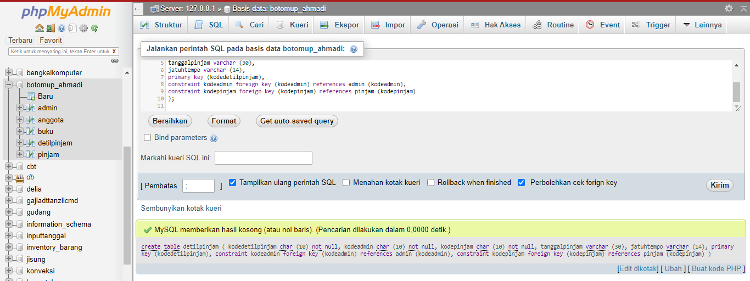

1. Memposting ke PHPMyadmin (desain skema tabel)

